**Problem 4, Part 2 R Code and Plot**

> theta<-c(0.0, 0.1, 0.2, 0.3, 0.4, 0.5, 0.6, 0.7, 0.8, 0.9, 1.0)

> Y<-rep(1,11)

> for(i in 1:11)

+ Y[i]<-choose(100,57)*(theta[i]^57)*(1-theta[i])^43

> print(Y)

**[1] 0.000000e+00 4.107157e-31 3.738459e-16 1.306895e-08 2.285792e-04 3.006864e-02**

**[7] 6.672895e-02 1.853172e-03 1.003535e-07 9.395858e-18 0.000000e+00**

>

> plot(theta, Y, type = "h", main = "Problem 4, Part 2", xlab = expression(paste(theta)),

+ ylab="Pr(Y=57 | theta)")

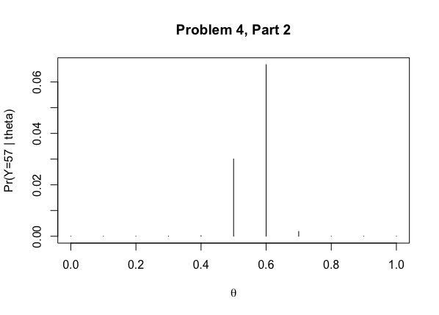

**Problem 4, Part 3 R Code and Plot**

> x<-rep(1,11)

> x1<-rep(1,11)

> for(i in 1:11)

+ x[i]<-(choose(100,57)*(theta[i]^57)*(1-theta[i])^43)*(1/11)

> NormConstant<-1/(sum(x))

> x1<-x*NormConstant

> print(x1)

**[1] 0.000000e+00 4.153701e-30 3.780824e-15 1.321705e-07 2.311695e-03 3.040939e-01**

**[7] 6.748515e-01 1.874172e-02 1.014907e-06 9.502335e-17 0.000000e+00**

>

> plot(theta, x1, type = "h", main = "Problem 4 Part 3", xlab = expression(paste(theta)),

+ ylab = "Posterior")

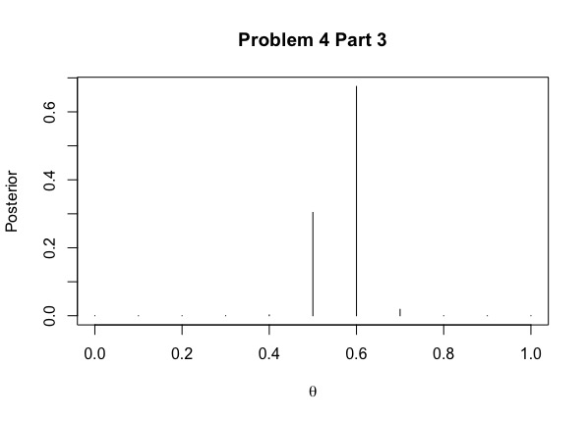

**Problem 4, Part 4 R Code and Plot**

f<-curve(choose(100,57)*x^57*((1-x)^43), from = 0, to = 1, main = "Problem 4, Part 4",

xlab = expression(paste(theta)), ylab = "posterior")

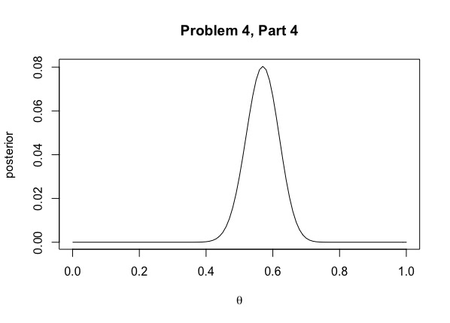

**Problem 4, Part 5 R Code and Plot**

v<-seq(0, 1, length = 200)

z<-dbeta(v, 58, 44)

plot(v, z, type = "l", main = "Problem 4, Part 5 Beta(58,44) Distribution",

xlab = expression(paste(theta)), ylab = "Posterior")

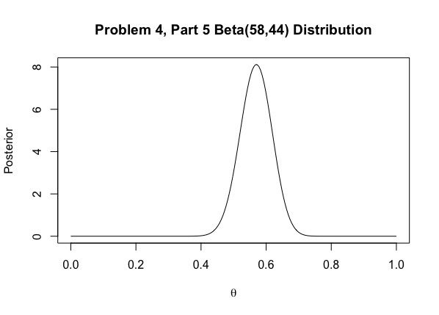

**Problem 5 R Code and Plot**

theta_0<-c(0.1, 0.2, 0.3, 0.4, 0.5, 0.6, 0.7, 0.8, 0.9)

n_0<-c(1,2,8,16,32)

a<-matrix(0L, nrow =length(theta_0), ncol =length(n_0))

b<-matrix(0L, nrow =length(theta_0), ncol =length(n_0))

for (i in 1:length(theta_0))

{for (j in 1:length(n_0))

{a[i,j]=theta_0[i]*n_0[j]

b[i,j]=(1-theta_0[i])*n_0[j]

}

}

Pr<-matrix(0L, nrow =length(theta_0), ncol =length(n_0))

for (i in 1:length(theta_0))

{for (j in 1:length(n_0))

{

f <- function(x)

{choose(100,57)*(x^57)*((1- x)^43)*(gamma(a[i,j]+b[i,j])/(gamma(a[i,j])*gamma(b[i,j])))*(x^(a[ i,j]-1))*(1-x)^(b[i,j]-1)}

bot<-integrate(f,0, 1, rel.tol=1e-10)$value

top<-integrate(f,0.5, 1, rel.tol=1e-10)$value

Pr[i,j]<-top/bot

}

}

contour(theta_0, n_0, Pr,main = "Problem 5 Countour Plot", xlab=expression(paste(theta)),

ylab='n_0')

